TR Series
Multi-Angle Portable Spectrophotometer
3-Angle / 6-Angle / 12-Angle Color Measurement
Capable of measuring sparkle,
color sparkle, flop index,
and graininess

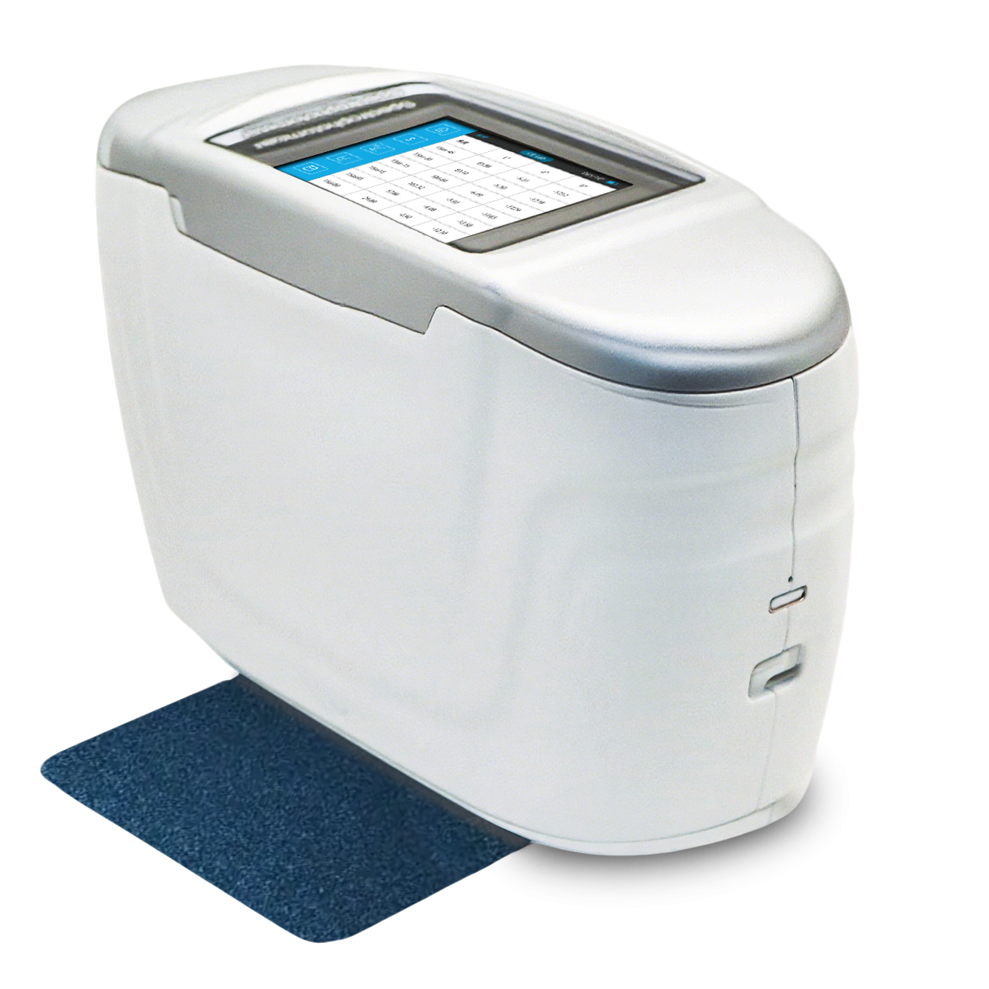
- Product Features
- Full-scene coverage: Up to 12 angles for accurate capture of automotive, plastic, cosmetics, and other effect finishes
- Four effect-parameter measurement system, ending the era of purely subjective evaluation
“subjective evaluation” in effect finish quality control
- 10-year / 5-million measurements light source revolution, setting a benchmark for industrial-grade reliability
- Outstanding 0.18 inter-instrument agreement, the “unified data language” for globalized production

- Measurement principle
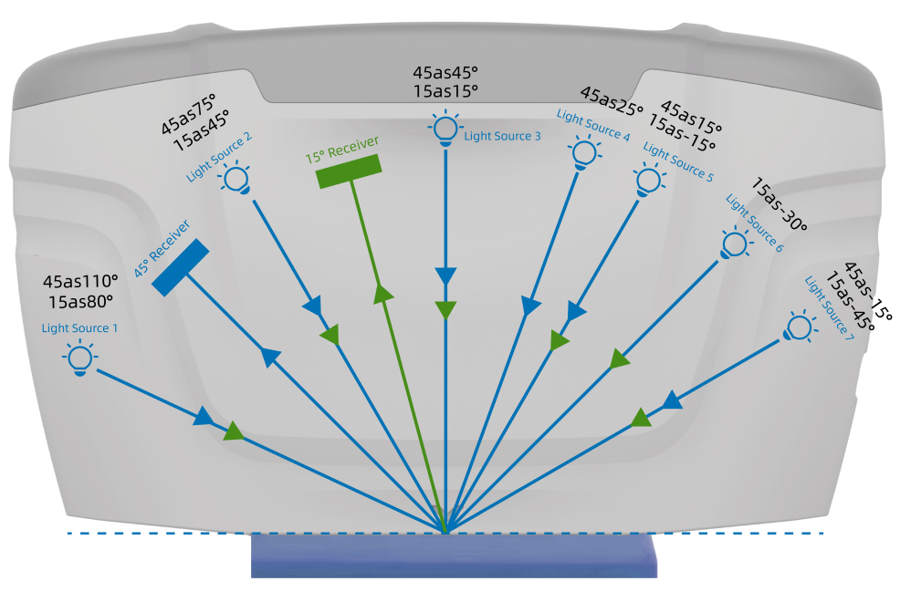

- Technical Parameters
Model | TR 5402/03 |  | TR 5402/06 | TR 5402/12
Measurement  Geometry | 3 angles  (3 light sources, 1 receiver) |  | 6 angles  (6 light sources, 1 receiver) | 12 angles  (7 light sources, 2 receivers)
Color Measurement Angles | 45° receiver：  45as15°,45as45°,45as110° |  | 45° receiver：  45as-15°,45as15°,45as25°,  45as45,45as75°,45as110° | 45° receiver：  45as-15°,45as15°,45  as25°,45as45°,  45as75°,45as110  15°receiver：  15as-45°,15as-15°,15as15°,  15as-30°,15as45°,15as80°
Illumination Source | Full-spectrum LED with blue-light enhancement
Light Source Lifetime | 10 years / 5 million measurements
Detector | 256-pixel dual-array CMOS image sensor
Spectral Range | 400nm-700nm
Measurement Aperture | Illumination Φ24mm / Sampling 9×12mm
Additional Indices | Flop Index, Color Travel Index
Measurement Time* | About 2.5s |  | About 4.5s | About 5s
Battery Life | Up to 5000 measurements
Color Repeatability | 0.02 ΔE*ab  (after warm-up calibration, 30 white tile measurements at 5s intervals, standard deviation)
Color Reproducibility | ΔE* < 0.10  (average on gray BCRA tiles); ΔE* < 0.25 (average on colored BCRA tiles)
Inter-instrument Agreement | 0.2 ΔE*00 (BCRA II, 12 tiles) |  |  | 0.18 ΔE*00  (BCRA II, 12 tiles)
Effect Parameters | / | Sparkle, Color Sparkle, Graininess
Effect  Measurement | / | - angle sparkle and graininess:  15as-45°, 15as-30°, 15as-15°, 15as15°, 15as45°, 15as80°; 15d diffuse graininess
Effect Repeatability | / | Sparkle short-term repeatability: 0.12%  (standard deviation of 10 measurements)  (After instrument warm-up calibration, average of 10 measurements on color tile at 10s intervals)  Graininess short-term repeatability: 0.09%  (standard deviation of 10 measurements)  (After instrument warm-up calibration, average of 10 measurements on color tile at 10s intervals)
Effect Reproducibility | / | Sparkle reproducibility: 1.9%  (standard deviation of 10 measurements)  (Average value from measurements on 12 BCRA Series II color tiles)  Graininess reproducibility: 1.4%  (standard deviation of 10 measurements)  (Average value from measurements on 12 BCRA Series II color tiles)
Positioning | Color camera preview
Display | 3.5-inch TFT true-color capacitive touchscreen
Data Storage | 10,000 records
Compliance Standards | ASTM D 2244,E 308,E 1164,E 2194,E2539,DIN 5033,5036,6174,6175-1,6175-2;IS07724,11664-4  ，SAE J 1545
Special Features | Provides precise and consistent color measurement for metallic, pearlescent, and other complex special-effect colors
Spectral Dispersion | Concave grating
Wavelength Interval | 10nm
Measurement Range | 0~600%
Half Bandwidth | 10nm
Color Spaces | CIE LAB,XYZ,Yxy,LCh,βxy.DIN Lab99,RGB,hunter Lab
Color Difference Formulas | ΔEab, ΔE94, ΔEcmc(2:1), ΔEcmc(1:1), ΔE00, DIN ΔE99, ΔE DIN6175, multiple automotive OEM formulas; Metamerism, ΔEab(Hunter), ΔEch, ΔE*uv
Observer Angles | 2°/10°
Observation Light Sources | A,B,C,D50,D55,D65,D75,F1,F2,F3,F4,F5,F6,F7,F8,F9,F10,F11,F12,CWF,U30,U35,DLF,NBF,TL83,TL84,  ID50,ID65,LED-B1,LED-B2,LED-B3,LED-B4,LED-B5,LED-BH1,LED-RGB1,LED-V1,LED-V2,LED-8
Display Functions | Spectral graph/data, sample color values, color difference values/graph, pass/fail results, color simulation, color bias, effect values, effect difference values
Trigger Modes | Pressure sensor, button trigger, software trigger
Measurement Modes | Single, average, continuous measurement
Dimensions | 194 × 73 × 118mm
Weight | About 850g
Interfaces | USB, Bluetooth
Languages | Simplified Chinese, Traditional Chinese, English
Operating  Conditions | 10°C–50°C, ≤85% RH, non-condensing
Storage Conditions | -20°C–50°C, ≤85% RH, non-condensing
Calibration | Built-in white reference, external white tile, black cavity, external color tile
Calibration Interval | 4h, 8h, 24h, or at startup
Standard Accessories | Power adapter, data cable, user manual, quality management software (download), calibration kit, protective cap, wrist strap
Optional Accessories | Mini printer

*Color measurement time
**Technical specifications are for reference only and are subject to the actual product sold

